# 

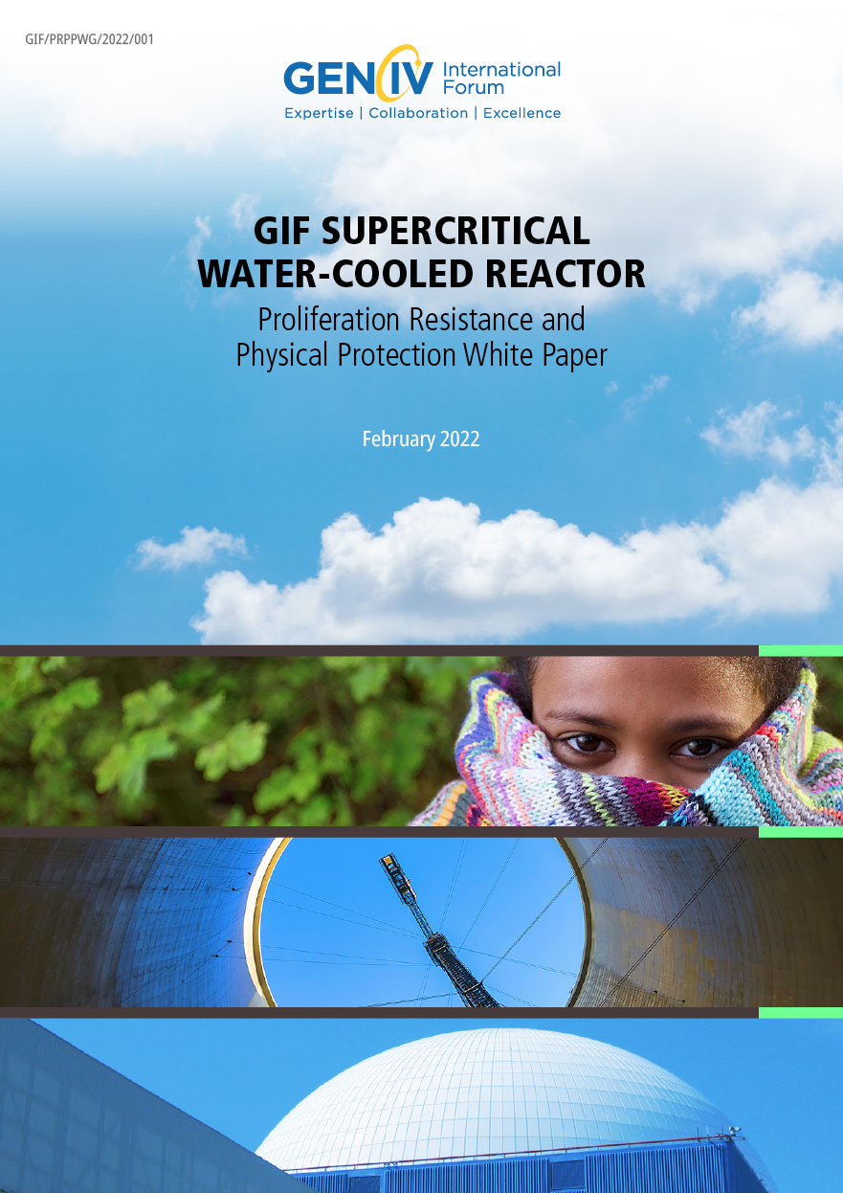 Fast Reactor System Steering

**DISCLAIMER**

This report was prepared by the Proliferation Resistance and Physical Protection Working Group (PRPPWG) and the Super Critical Water Reactor System Steering Committee of the Generation IV International Forum (GIF). Neither GIF nor any of its members, nor any GIF member’s national government agency or employee thereof, makes any warranty, express or implied, or assumes any legal liability or responsibility for the accuracy, completeness or usefulness of any information, apparatus, product, or process disclosed, or represents that its use would not infringe privately owned rights. References herein to any specific commercial product, process or service by trade name, trademark, manufacturer, or otherwise, does not necessarily constitute or imply its endorsement, recommendation, or favoring by GIF or its members, or any agency of a GIF member’s national government. The views and opinions of authors expressed therein do not necessarily state or reflect those of GIF or its members, or any agency of a GIF member’s national government.

Cover page photos: © Delovely Pics/Shutterstock - © Delovely Pics/Shutterstock - © Pyty /Shutterstock

# Preface to the 2021 edition of the SSCs, pSSCs & PRPPWG white papers on the PR&PP features of the six GIF technologies

This report is part of a series of six white papers, prepared jointly by the Proliferation Resistance and Physical Protection Working Group (PRPPWG) and the six System Steering Committees (SSCs) and provisional System Steering Committees (pSSCs). This publication is an update to a similar series published in 2011 presenting the status of Proliferation Resistance & Physical Protection (PR&PP) characteristics for each of the six systems selected by the Generation IV International Forum (GIF) for further research and development, namely: the Sodium-cooled fast Reactor (SFR), the Very high temperature reactor (VHTR), the gas-cooled fast reactor (GFR), the Molten salt reactor (MSR) and the Supercritical water–cooled reactor (SCWR).

The Proliferation Resistance and Physical Protection Working Group (PRPPWG) was established by GIF to develop, implement and foster the use of an evaluation methodology to assess Generation IV nuclear energy systems with respect to the GIF PR&PP goal, whereby: Generation IV nuclear energy systems will increase the assurance that they are a very unattractive and the least desirable route for diversion or theft of weapons-usable materials, and provide increased physical protection against acts of terrorism.

The methodology provides designers and policy makers a technology neutral framework and a formal comprehensive approach to evaluate, through measures and metrics, the Proliferation Resistance (PR) and Physical Protection (PP) characteristics of advanced nuclear systems. As such, the application of the evaluation methodology offers opportunities to improve the PR and PP robustness of system concepts throughout their development cycle starting from the early design phases according to the PR&PP by design philosophy. The working group released the current version (Revision 6) of the methodology for general distribution in 2011. The methodology has been applied in a number of studies and the PRPPWG maintains a bibliography of official reports and publications, applications and related studies in the PR&PP domain.

In parallel, the PRPPWG, through a series of workshops, began interaction with the Systems Steering Committees (SSCs) and Provisional Systems Steering Committees (pSSCs) of the six GIF concepts. White papers on the PR&PP features of each of the six GIF technologies were developed collaboratively between the PRPPWG and the SSCs/pSSCs according to a common template. The intent was to generate preliminary information about the PR&PP merits of each system and to recommend directions for optimizing its PR&PP performance. The initial release of the white papers was published by GIF in 2011 as individual chapters in a compendium report.

In April 2017, as a result of a consultation with all the GIF SSCs and pSSCs, a joint workshop was organized and hosted at OECD-NEA in Paris. During two days of technical discussions, the advancements in the six GIF designs were presented, the PR&PP evaluation methodology was illustrated together with its case study and other applications in national programmes. The need to update the 2011 white papers emerged from the discussions and was agreed by all parties and officially launched at the PRPPWG meeting held at the EC Joint Research Centre in Ispra (IT) in November 2017.

The current update reflects changes in designs, new tracks added, and advancements in designing the six GIF systems with enhanced intrinsic PR&PP features and in a better understating of the PR&PP concepts. The update uses a revised common template. The template entails elements of the PR&PP evaluation methodology and allows a systematic discussion of the systems elements of the proposed design concepts, the potential proliferation and physical protection targets, and the response of the concepts to threats posed by a national actor (diversion & misuse, breakout and replication of the technology in clandestine facilities), or by a subnational/terrorist group (theft of material or sabotage).

The SSCs and pSSC representatives were invited to attend PRPPWG meetings, where progress on the white papers was discussed in dedicated sessions. A session with all the SSCs and pSSCs was organized in Paris in October 2018 on the sideline of the GIF 2018 Symposium. A drafting and reviewing meeting on all the papers was held at Brookhaven National Laboratory in Upton, NY (US) in November 2019, followed by a virtual meeting in December 2020 to discuss all six drafts.

Individual white papers, after endorsement by both the PRPPWG and the responsible SSC/pSSC, are transmitted to the Expert Group (EG) and Policy Group (PG) of GIF for approval and publication as a GIF document. Cross-cutting PR&PP aspects that transcend all six GIF systems are also being updated and will be published as a companion report to the six white papers.

**Abstract**

This white paper represents the status of Proliferation Resistance and Physical Protection (PR&PP) characteristics for the Supercritical Water-cooled Fast reactor (SCFR) reference designs selected by the Generation IV International Forum (GIF) SCWR System Steering Committee (SSC). The intent is to generate preliminary information about the PR&PP features of the SCWR reactor technology and to provide insights for optimizing their PR&PP performance for the benefit of SCWR system designers. It updates the SCWR analysis published in the 2011 report “Proliferation Resistance and Physical Protection of the Six Generation IV Nuclear Energy Systems”, prepared Jointly by the Proliferation Resistance and Physical Protection Working Group (PRPPWG) and the System Steering Committees and provisional System Steering Committees of the Generation IV International Forum, taking into account the evolution of both the systems, the GIF R&D activities, and an increased understanding of the PR&PP features.

The white paper, prepared jointly by the GIF PRPPWG and the GIF SCWR SSC, follows the high-level paradigm of the GIF PR&PP Evaluation Methodology to investigate the PR&PP features of the eight proposed GIF SCWR designs. Two small modular reactors, the Canadian SSR and the Canada/China/Europe ECC-SMART are also mentioned. An overview of the fuel cycles for the GIF designs are provided. For PR, the document analyses and discusses the proliferation resistance aspects in terms of robustness against State-based threats associated with diversion of materials, misuse of facilities, breakout scenarios, and production in clandestine facilities. Similarly, for PP, the document discusses the robustness against theft of material and sabotage by non-State actors. The document follows a common template adopted by all the white papers in the updated series.

**List of Authors**

|  |  |  |  |
| --- | --- | --- | --- |
| Geoffrey Edwards | PRPPWG | | Canadian Nuclear Laboratories, Canada |
| Laurence Leung | PRPPWG | | Canadian Nuclear Laboratories, Canada |
|  |  |  | |

**Acknowledgements**

The original 2011 white paper for SCWR was written by Laurence Leung (Canadian Nuclear Laboratories - CNL). This current adaptation was written by Geoffrey Edwards and Laurence Leung, with assistance from Bryan van der Ende and Sam Kelly, all at CNL. Special thanks is also owed the Proliferation Resistance and Physical Protection Working Group (PRPPWG), particularly to Brian Boyer (International Atomic Energy Agency), Giacomo G.M. Cojazzi (EC Joint Research Centre) and Lap Cheng (Brookhaven National Laboratory), for helping with the construction of this paper. Very helpful updates to their respective systems and proofreading of the paper, by the Japanese and Russian representatives to the SCWR System Steering Committee are also gratefully acknowledged.

A special thanks to the GIF Technical Secretary Gina Abdelsalam (OECD-NEA) who ably readied the final manuscript for publication.

**Table of contents**

**1. Overview of Technology 1**

1.1 The Canadian Thermal-Spectrum SCWR 5

1.2 The Chinese Thermal-Spectrum SCWR 5

1.3 The EU Thermal-Spectrum SCWRs 5

1.4 The Japanese Thermal-Spectrum SCWR 5

1.5 The Chinese Mixed-Spectrum SCWR 5

1.6 The Japanese Fast-Spectrum SCWR 5

1.7 The Russian Mixed and Fast-Resonant Spectrum SCWR 6

1.8 Non-GIF concepts 6

2. Overview of Fuel Cycles 7

2.1 The Canadian Thermal-Spectrum SCWR 12

2.2 The Chinese Thermal-Spectrum SCWR 12

2.3 The Euratom Thermal-Spectrum SCWR 12

2.4 The Japanese Thermal-Spectrum SCWR 12

2.5 The Chinese Mixed-Spectrum SCWR 12

2.6 The Japanese Fast-Spectrum SCWR 13

2.7 The Russian Mixed-Spectrum SCWR 13

2.8 The Russian Fast-Resonant Spectrum SCWR 13

3. PR&PP Relevant System Elements and Potential Adversary Targets 14

3.1 SCWRs with a once-through fuel cycle 14

3.2 SCWRs with recycling in the fuel cycle 17

4. Proliferation Resistance Features 20

4.1 Concealed diversion or production of material 22

4.1.1 Diversion of unirradiated nuclear material items 22

4.1.2 Diversion of irradiated nuclear material items 23

4.1.3 Undeclared production of nuclear material 23

4.2 Breakout 23

4.2.1 Diversion of existing nuclear material 24

4.2.2 Production of the necessary weapons usable material 24

4.3 Production in clandestine facilities 24

4.4 Overview of proliferation resistance features 24

5. Physical Protection Features 24

5.1 Theft of material for nuclear explosives 24

5.2 Radiological sabotage 25

6. PR&PP Issues, Concerns, and Benefits 27

7. References 28

APPENDIX 1: Summary of PR relevant intrinsic design features 31

**List of Figures**

Figure 1: SCWR Concepts 1

Figure 2: SCWR Plant Concepts 3

Figure 3: Thermal-Spectrum SCWR Core Configurations 4

Figure 4: Mixed- and Fast-Spectrum SCWR Core Configurations 4

Figure 5: Thermal-Spectrum SCWR Fuel Concepts 7

Figure 6: Mixed- and Fast-Spectrum SCWR Fuel Concepts 8

Figure 7: PR&PP Relevant System Elements at a SCWR Reactor Site 16

Figure 8: System Elements for all SCWR types 17

Figure 9: VVER-SCP-600 SNF reprocessing 18

Figure 10: System Elements of the VVER-SCP-600 19

**List of Tables**

Table 1: Key Parameters of SCWR concept 3

Table 2: Fresh fuel characteristics of SCWR considered designs 9

Table 3: Spent fuel characteristics of considered designs of SCWR 11

Table 4: Assignment of PR&PP System Elements to Different Designs 16

**List of Acronyms**

BWR Boiling Water Reactor

CNL Canadian Nuclear Laboratories

DGR Deep Geological Repository

ECC-SMART European Canadian Chinese -Small Modular Reactor Technology

EU European Union

FA Fuel Assemblies

FR Fast Reactor

GIF Generation-IV International Forum

HALEU High-Assay LEU

HE Heavy Element

HEU High Enriched Uranium

HWR Heavy Water Reactors

IAEA International Atomic Energy Agency

IDU Irradiated Direct Use

IU Indirect Use

JAEA Japan Atomic Energy Agency

LEU Low Enriched Uranium

LWR Light Water Reactor

MOX Mixed Oxide

PP Physical Protection

PR Proliferation Resistance

PT Pressure Tube

PV Pressure Vessel

PR&PP Proliferation Resistance & Physical Protection

PWR Pressurized Water Reactor

SC Super Critical

SCWR Supercritical Water-cooled Reactor

SMR Small Modular Reactor

SSC System Steering Committee

SSR Supersafe Reactor

SQ Significant Quantity

UDU Unirradiated Direct Use

UK United Kingdom

UOX Uranium Oxide

VVER Voda-Voda Energo Reactor

(This page has been intentionally left blank)

## Overview of Technology

The Super-Critical Water-cooled Reactor (SCWR) [1] is a high temperature, high-pressure water-cooled reactor that operates above the thermodynamic critical point, 374oC (647 K) and 22.1 MPa. The main improvement in the SCWR is in the area of economics due to the high thermal efficiency and simplifications that result from the use of supercritical (SC) water as coolant. Furthermore, the safety characteristics of the SCWR have also been advanced by the introduction of additional passive safety systems. Depending on the conceptual configuration, proliferation resistance and physical protection (PR&PP) aspects can have improved features.

Two reactor concepts, using either pressure vessels or pressure tubes (**Figure 1**), are being considered for the SCWR. These are represented in three common configurations:

a) a pressure-vessel type (left-hand side of **Figure 1**), and

b) a pressure-tube type reactor (right-hand side of **Figure 1**).

c) a pressure-vessel type reactor in a two-circuit nuclear power installation (bottom of Figure 1)

|  |  |
| --- | --- |
|  |  |
| **Figure 1: SCWR Concepts [2]** | |

In addition to the primary circuit differences, thermal, fast and mixed spectra are all possible in the SCWR design. The combination of primary circuit and spectrum provides several options for the SCWR [2] [3] [4] [5] [6] [7] [8] [9] [10] [11] [12] [13] [14].

The reference fuel for the SCWR is UO2 or thorium for thermal‑spectrum concepts and MOX for fast‑spectrum (and fast-resonant-spectrum) concepts. The UO2 fuel composition is similar to those used in Gen-III and Gen-III+ technologies. The reference thorium fuel composition consists of a mix of thorium and plutonium oxides in the pressure-tube type of SCWRs.

The safety approach is based on Gen III+ technology with additional passive safety systems. The compactness of the SCWR core leads to reductions in the footprint and containment size, which have positive implications for protection against external events. The elimination of steam generators in the non-Russian Federation systems also reduces footprint and containment size but, on the other hand, introduces the nuisance of the requirement of radioprotection of the turbine island against flow impurities activated in the reactor.

Key parameters of the individual SCWR concepts are reproduced here in Table 1 Canada, the European Union (though Euratom) and Japan (**Figure 2**) have successfully completed the development of their SCWR concepts, which were reviewed by international peers. Both Canada’s and Euratom’s core concepts are developed for the thermal spectrum. On the other hand, Japan has developed two core concepts with one at the thermal spectrum and another at the fast spectrum (both having the same plant concept). China and the Russian Federation are continuing their development of their pressure-vessel type of core concepts. However, while China is developing a thermal-spectrum and a mixed-spectrum core concept, the Russian Federation is working on a mixed spectrum and on a fast-resonant-spectrum core concept.

Table 1: Key Parameters of SCWR concept

|  |  |  |  |  |  |  |  |  |
| --- | --- | --- | --- | --- | --- | --- | --- | --- |
|  | **Canada**  **SCWR** | **China**  **CSR1000** | | **EU**  **HPLWR** | **Russian Federation**  **VVER-SKD VVER-SCP-600** | | **Japan**  **Super LWR Super FR** | |
| Type | PT | PV | PV | PV | PV | PV | PV | PV |
| Spectrum | Thermal | Thermal | Mixed | Thermal | Mixed | Fast-resonant | Thermal | Fast |
| Pressure (MPa) | 25 | 25 | 25 | 25 | 24.5 | 27.5 | 25 | 25 |
| Inlet Temp. (°C) | 350 | 280 | 280 | 280 | 290 | 400 | 280 | 280 |
| Outlet Temp. (°C) | 625 | 500 | 510 | 500 | 540 | 520 | 500 | 501 |
| Thermal Power (MW) | 2540 | 2300 | 3800 | 2300 | 3830 | 1250 | 3492 | 2337 |
| Efficiency (%) | 48 | 43 | 44 | 43.5 | 45 | 46.4 | 43.8 | 43 |
| Active Core Height (m) | 5 | 3 | 4.5 | 4.2 | 4.05(1-path)  3.76(2-path) | 0.8 | 4.2 | 2.4 |
| Fuel | (Pu,Th)O2 | UO2 | UO2/MOX | UO2 | MOX | MOX | UO2 | MOX |
| Burnup (GWd/t HE[1]) | 60 | 45 | ? | 60 | 40 (60) | 54 | 45.3[2] | 53.8/72.7[3] |
| Moderator[4] | D2O | H2O | H2O/‑ | H2O | H2O | - | H2O | ‑/ZrH1.7 |
| # of Flow Passes | 1 | 2 | 2 | 3 | 1 (2) | 1 | 1 | 1 |
| Blanket | No | No | Yes | No | No | Yes | No | Yes |

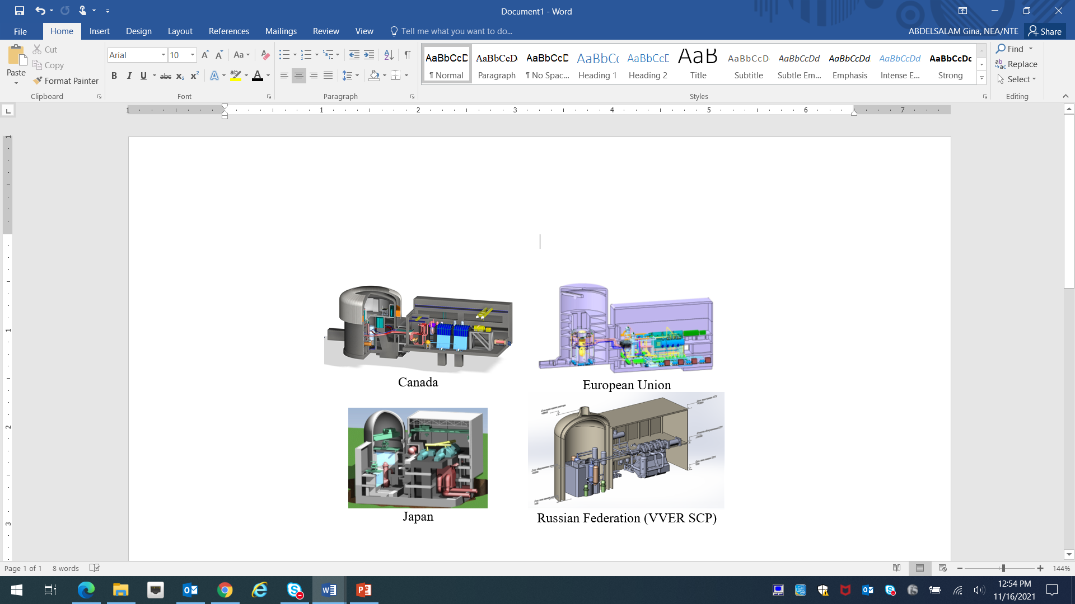

**Figure 2: SCWR Plant Concepts [2]** [13**]** Error! Reference source not found.**]**

The SCWR thermal-spectrum core concepts mostly use the pressure-vessel configuration, with the exception of the Canadian concept based on the pressure-tube configuration. Coolant circulates from the bottom to the top of fuel assemblies in a single path for both the Japanese and Canadian concepts. However, it passes through two zones of fuel assemblies (two-path system) in the Chinese concept and three zones (three-path system) in the EU concept. **Figure 3** illustrates the thermal-spectrum core configurations. The cores of the mixed- and fast-spectrum core concepts are shown in **Figure 4**.

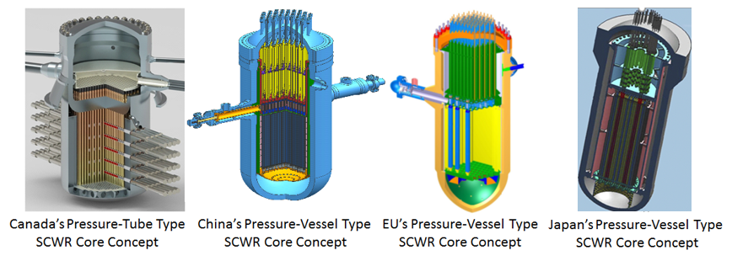

**Figure 3:** **Thermal-Spectrum SCWR Core Configurations [2] [11]**

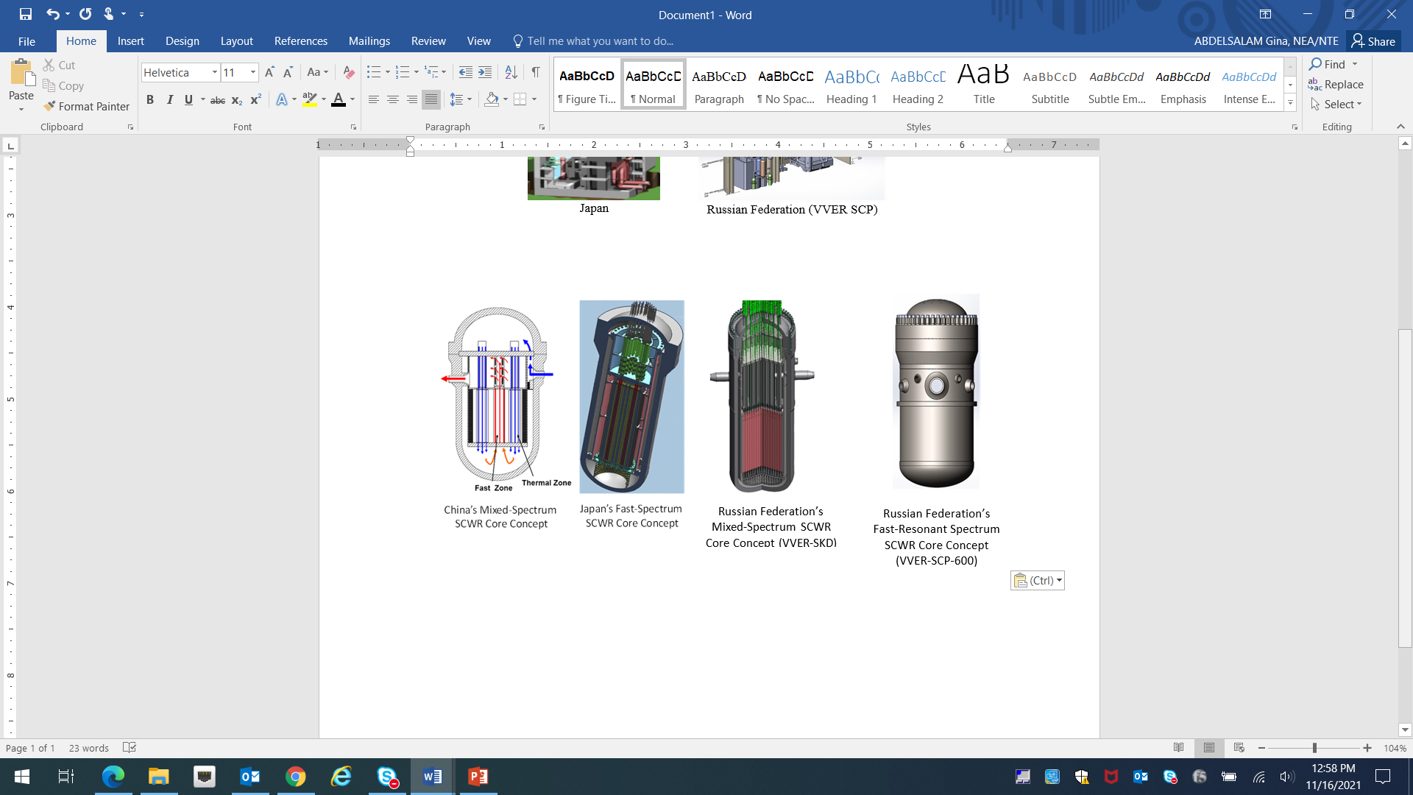

**Figure 4: Mixed- and Fast-Spectrum SCWR Core Configurations [2] [11]** [13**]** [14**]**

## 1.1 The Canadian Thermal-Spectrum SCWR [2] [10]

Canada’s concept consists of an inlet plenum, where the coolant enters the core and distributes to the fuel channels, and an outlet header, which collects the high-temperature coolant from the fuel channels and directs it to the high-pressure turbine. The fuel channels are submerged within the low-pressure D2O moderator in the calandria vessel. Control and shutdown rods insert from the side of the calandria vessel into the moderator.

## 1.2 The Chinese Thermal-Spectrum SCWR [3]

Coolant enters the vessel from the inlet nozzles and is divided into two streams. In the Chinese concept, most of the coolant travels up the passage beside the vessel wall and down through the first zone of fuel assemblies. It mixes with the remaining coolant in the lower plenum and travels up through the second zone of fuel assemblies. The remaining coolant entering the vessel flows down to the lower plenum and mixes with the bulk coolant.

## 1.3 The EU Thermal-Spectrum SCWRs [2]

The EU core concept has a similar configuration to that of the Chinese, except that the EU concept has three fuel zones, while that of China has two zones.

In the EU concept, most of the coolant travels down the passage beside the vessel wall and up through the first zone of fuel assemblies. The remaining coolant flows up another passage to the top of the vessel, mixes with the coolant through the first zone, down through the second zone and up through the third zone of fuel assemblies. The high-temperature coolant collected at the outlet header is directed to the high-pressure turbine. Control and shutdown rods are inserted from the top of the vessel into the core.

## 1.4 The Japanese Thermal-Spectrum SCWR [6] [7] [8]

The Japanese core concept is similar to that of a pressurized water reactor (PWR). Coolant flow scheme in the vessel is the same as that of a PWR. Coolant enters the reactor vessel from the inlet nozzles and flows downward between the vessel and shroud. It enters into the bottom head of the vessel, flows upward into the core and flows out into the upper plenum. The coolant scheme is called "single-pass core", and is a modification of earlier designs, which had a two pass coolant flow. The vessel wall is cooled by the inlet coolant. The outlet coolant nozzles of the vessel are equipped with thermal sleeves for mitigating thermal stress. Control and shutdown rods insert from the top of the vessel as in a PWR. The required high temperatures of 500 °C across the core are obtained by breaking the core into central and peripheral assemblies of different types and different flow to power ratios.

## 1.5 The Chinese Mixed-Spectrum SCWR [4]

A mixed-spectrum SCWR core concept is being developed at the Shanghai Jiao Tong University in China. Its configuration is similar to that of China’s thermal-spectrum core. The first zone of fuel assemblies is the thermal-spectrum region while the second zone is the fast-spectrum region. Control and shutdown rods are also insert from the top of the vessel to the core.

## 1.6 The Japanese Fast-Spectrum SCWR [6] [7] [8]

The configuration of Japan’s fast-spectrum core concept differs from that of the thermal-spectrum core concept. The whole core is cooled with upward coolant flow in one through flow pattern like PWR. Compared with the previous two pass core design, this new flow pattern significantly simplifies the core concept in terms of upper core structure, coolant flow scheme as well as refueling procedure. Control and shutdown rods insert through the top of the vessel into the core.

## 1.7 The Russian Mixed and Fast-Resonant Spectrum SCWR [5] [12][13][14]

The Russian Federation’s SCWR concept has two options:

* 1) Single-circuit (VVER-SKD);
* 2) Two-circuit (VVER-SCP).

The first option (VVER-SKD) adopts a single-path or two-path flow pattern. In the single-path core concept, the coolant passes through the downcomer, enters the core from the lower plenum and then flows upward to the outlet plenum. In the two-path core concept the main part of the coolant enters the core and travels downward through the outer core zone to the lower plenum of reactor and then turns and flows upward through the inner core zone to the outlet of the vessel. A minor part of the coolant entering the reactor vessel goes to the lower plenum via the reactor downcomer and mixes there with the coolant from the outer core zone. Coolant leaving the reactor goes to the high-pressure cylinder of the turbine. A mixed neutron spectrum is realized in the core.

The second option (VVER-SCP) is a reactor having a two-circuit nuclear power installation with an indirect power conversion system. The core of this reactor has a tight fuel lattice and a supercritical pseudo-vapor coolant of 27.5 MPa entering reactor with temperature of 400oC and leaving it with averaged temperature of 520oC. Reactor is characterized by fast-resonant neutron spectrum and moderate volumetric power load. The secondary circuit has a turbine installation with supercritical steam at the entrance of 27.5 MPa and 500oC. In the first circuit of the reactor installation the primary coolant is pumped through the reactor by the main circulation pump and then goes to the once-through vertical steam generator, where the primary coolant transfers its heat to the secondary circuit.

## 1.8 Non-GIF concepts

A small modular reactor (SMR) variant of the Canadian thermal spectrum SCWR, called the Supersafe© reactor (SSR) [16], has been developed as a concept. It shares many design features with the Canadian SCWR, including pressure tubes, coolant path, low pressure moderator and assembly design. The power output has been scaled to 670 MW (thermal), approximately 26% of the full sized reactor. Therefore, the expected exit burnup is 44 GWd/t instead of 60.

An international collaboration was established in September 2020 to further the current knowledge on the SCWRs technology, including SC SMRs. This program is supported by the European Union under the Horizon 2020 platform. This project is named the European Canadian Chinese development of Small Modular Reactor Technology (ECC‑SMART[5]). The joint initiative is oriented towards assessing the feasibility and identification of safety features of an intrinsically and passively safe small modular reactor cooled by supercritical water (SCW-SMR). The project encompasses the design and pre-licensing requirements as well as a roadmap for demonstration of safety.

# Overview of Fuel Cycles

Fuel concepts for thermal-spectrum cores are fuel rods similar in geometry to those of LWRs. **Figure 5** illustrates the fuel assemblies for the SCWR thermal-spectrum cores. Differences are mainly in the spacing devices and the introduction of water in the central region of the fuel assembly to enhance the moderation of the coolant at high pressure and high-temperature conditions. Fuel assembly concepts for mixed- and fast-spectrum SCWRs are illustrated in **Figure 6**.

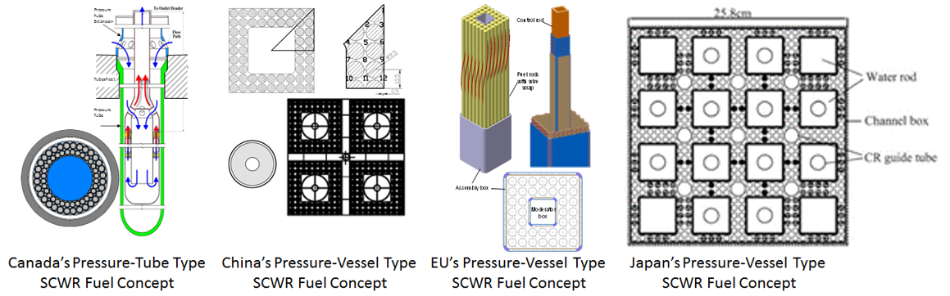

**Figure 5: Thermal-Spectrum SCWR Fuel Concepts [2] [3] [6] [7] [8]**

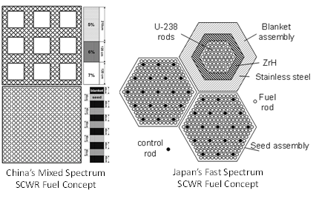

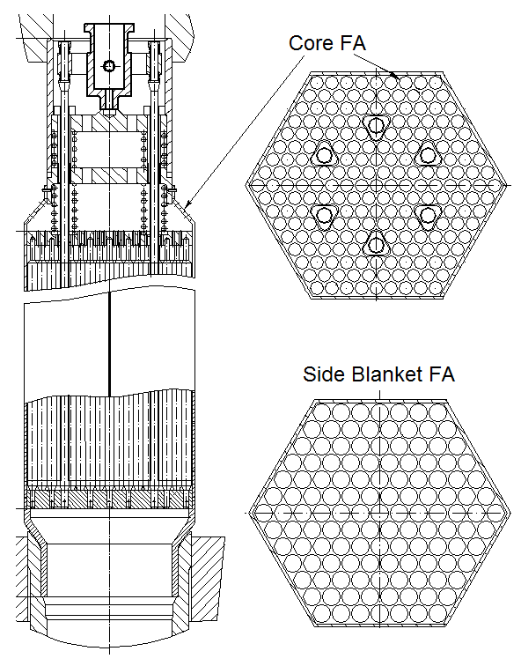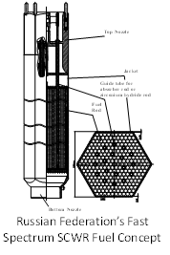

Russian Federation’s Fast-Resonant- Spectrum SCWR Core Concept (VVER-SCP-600)

Russian Federation’s Mixed-Spectrum SCWR Core Concept (VVER-SKD)

**Figure 6****: Mixed- and Fast-Spectrum SCWR Fuel Concepts [4] [5] [6] [7] [8] [10]** [12**]**

All the fuel cycle concepts envisioned for the SCWRs, excepting the Russian Federation concept VVER SCP, are once-through fuel cycles. The VVER SCP utilizes a closed fuel cycle with recycling of spent fuel into fresh fuel. However, future reprocessing of fuel to recover unused fissile material, and bred-in fissile material, is foreseen for all concepts. Of the eight SCWR types presented in Table 1, the fuel cycles of six of the SCWRs appear in more detail in Table 2. Fuel cycle data for the Chinese and Russian mixed spectrum reactors was insufficient for an in-depth analysis. The most important fuel cycle parameters for PR&PP for the six reactors with sufficient data are summarized in Tables 2 (fresh fuel) and 3 (spent fuel).

Table 2: Fresh fuel characteristics of SCWR considered designs

|  |  |  |  |  |  |  |  |  |
| --- | --- | --- | --- | --- | --- | --- | --- | --- |
|  | **Canada** | **China** | | **EU** | **Russia** | | **Japan** | |
| Name | SCWR | CSR1000 | ? | HPLWR | VVER-SKD | VVER-SCP-600 | Super LWR | Super FR |
| Spectrum | Thermal | Thermal | Mixed | Thermal | Mixed | Fast-Resonant | Thermal | Fast |
| Thermal Power (MW) | 2540 | 2300 | 3800 | 2300 | 3830 | 1250 | 3492 | 2337 |
| Fuel | (Pu,Th)O2 | UO2 | UO2/MOX | UO2 | MOX | MOX | UO2 | MOX |
| Regions | Inner/Outer | Inner/Outer | No data | Inn./Mid./Out. | No data | Core/Blankets | Inner/Outer | Blanket/Seed |
| Fissile Component | 17.7/13.7%  Pu in Pu+Th | 5.6-6.2% U-235 in U  (same for inner and outer regions) | 9% and 9.5% U-235/U, depending on axial position. (same for all core regions) | 24% Pu,  0.2% U-235 in DU | 6.4 – 7.9%  U-235 in U  (7.31% average) | Blanket bottom/top  Pu= 10%/0% (DU)  Seed bottom/top  Pu= 32%/25%[6] |
| HE per Assembly | 154.2 kg | 601.5 kg | 480.8 kg U | 78 kg | 507/460 kg | 193.4/345.8 kg |
| Fissile/Assembly | 20.4 kg Pu | 37.3 kg U-235 | 44.5 kg U-235 | 19.52 kg | 38/34 kg U-235 | 3.22/106.6 kg Pu |
| SQ[7]/Assembly | **2.55** | **0.5** | **0.59** | **2.44[8]** | **0.46** | **0.4/13.33** |
| Assemblies/Batch | 112 | 52 | 24 | 70 | 6.2/19.4[9] | 37/26  Blanket/Seed |
| HE per Batch | 17.27 t | 31.3 t U | 11.5 t U | 5.5 t | 3.69/10.02 t | 7.15/8.99 t |
| Fissile per Batch | 2.28 t Pu | 1.94 t U-235 | 1.07 t U-235 | 0.87 t | 0.89 t U-235 | 0.119/2.772 t Pu |
| SQ/Batch | **285** | **25.9** | **14.2** | **170.31** | **11.81** | **14.9/346.5** |

The Japanese fast reactor [9], the Super FR, contains blanket fuel assemblies. The lower 60 cm of blanket assemblies contain 10% Pu in HE, while the upper 200 cm is depleted uranium (DU) with 0.2% U-235 in HE. The plutonium bred into this blanket region contributes to the overall reactor power during its time in the core.

The thermal reactors do not rely on breeding fissile material in separate regions. Pu is bred into the UO2 fuelled reactors and U-233 into the thorium fueled Canadian SCWR, but this happens coincidentally with the burning of fissile material in the same fuel.

The recycling of plutonium from the thermal and fast reactors is foreseen after prototype reactors have been demonstrated. The recycling of U-233 from the Canadian SCWR back into fresh fuel, eventually displacing Pu as the starting fissile component, has been extensively studied in the context of other thorium-fueled heavy water reactors (HWRs) [19] [20] [21] [22].

IAEA safeguards [16] has definitions of grades of nuclear materials that reflect the strategic value of nuclear material as a relative measure of the usefulness of an amount of nuclear material and ease of conversion into a weaponizable form to a potential diverter for producing nuclear explosives. The IAEA defines two categories of nuclear material. There is direct-use material nuclear material that can be used for the manufacture of nuclear explosives components without transmutation or further enrichment, such as plutonium containing less than 80% Pu-238 [25], uranium enriched 20% and higher in U‑235 (high enriched uranium (HEU)) and U-233. Chemical compounds, mixtures of direct-use materials, such as MOX and thorium and U-233 mixtures, transuranic fuels, and plutonium contained in spent nuclear fuel also fall into this category. Unirradiated direct-use (UDU) material would require less processing time and effort as opposed to the category of irradiated direct-use (IDU) material (contained in spent fuel). Indirect-use (IU) material encompasses all nuclear material except direct-use material such as natural uranium, or LEU which must be further enriched to be converted into HEU or inserted into a reactor to produce Pu-239 which can be separated in a reprocessing plant, or thorium which needs irradiation to produce U-233 which can be separated in a reprocessing plant. Tables 2 and 3 show the characteristics of the nuclear materials for the SCWRs under study.

Average core and exit burnup compositions not being available for most of the reactors, a number of assumptions have been made in Table 3. It was assumed that the average fissile component of assemblies in the core was half the fresh value, and that local storage bays would accept 10 years’ worth of spent fuel (after which either recycling or disposal would occur). The cycle time (for spent fuel unload and fresh fuel reload) was therefore divided into 10 years to determine the average number of spent fuel items in the bays This latter requirement assumes that fuel will be recycled after this much time, although recycling is not built into the designs at the current moment.

Table 3: Spent fuel characteristics of considered designs of SCWR

|  |  |  |  |  |  |  |  |  |
| --- | --- | --- | --- | --- | --- | --- | --- | --- |
|  | **Canada** | **China** | | **EU** | **Russia** | | **Japan** | |
| Name | SCWR | CSR1000 | ? | HPLWR | VVER-SKD | VVER-SCP-600 | Super LWR | Super FR |
| Fuel | (Pu,Th)O2 | UO2 | UO2/MOX | UO2 | MOX | MOX | UO2 | MOX |
| Regions | Average | Average | No data | Average | No data | Core/Blankets | Central/Peripheral | Blanket/Seed |
| Specific power | 44.15 MW/t HE | 24.4 MW/ t HE | 30.7 MW/ t HE | 63 MW/ t HE | 55.70/36.5  MW/t HE | 24.8 MW/t HE  80.4 MW/t HE |
| FPD/Assembly | 1359.8 | 1847.7 d | 1957 d | 1320 d | 895.8 d | 600 d (Seed)  200 d (Blanket) |
| Specific Burnup | 60.0 GWd/t HE | 45.0 GWd/ t HE | 60.0  GWd/t HE | 54.0 GWd/t HE | 45.9/29.1  GWd/t HE | 48.30/4.95  Seed/Blanket  GWd/t HE |
| Ass. per batch | 112 | 52 | 26 | 70 | 19.2/6.4 | 26/37  Blanket/Seed |
| Number of batches | 3 | 3 | 6 | 4 | 5 | 1+3  Blanket+Seed |
| Cycle time[10] | 453.3 d | 615.9 d | 326 d | 330 d | 179 FPD[11] | 600/200 FPD |
| Core fissile in SQ (Type of fissile) | 55.43 (Pu)  6.80 (U-233) | 105.5 (Pu)  39.0 (U-235) | 93.6 (Pu)  46.2 (U-235) | 301 Pu | 37.7 (Pu)  13.7 (4% U-235)[12] | 1054.3 (Pu)  ~0 (U-235) |
| Cooling bay contents in SQ  (Type of fissile) | 147.8 (Pu)  18.14 (U-233) | 209.7 (Pu)  15.8 (U-235) | 144 (Pu)  1.41 (U-235) | 602 Pu | 66.9 (Pu)  28.9 (4% U-235) | 6866.3 (Pu)  ~0 (U-235) |

## 2.1 The Canadian Thermal-Spectrum SCWR

The fuel concept for Canada’s SCWR consists of a flask-like structure that contains the fuel assembly and is connected to the outlet header. Several nozzles are introduced for the coolant entering into the structure. These nozzles, along with another set of openings installed at the top of the pressure tube, also serve as orifices to control the flow rate to control the power generation in the channel. The fuel assembly resembles a string of circular-geometry fuel bundles similar to those of HWRs. In this concept the fuel bundles have two rings of 32 fuel rods and the overall active length of fuel is 5 metres. Spacing between fuel rods is maintained with wire-wrapped spacers. A central flow tube is installed for the coolant to travel down from the nozzles to the bottom of the fuel channel. This flow tube also improves the moderation for the inner-ring rods, resulting in a balanced radial power profile. From the bottom plenum, the coolant travels upward through the fuel assembly to the outlet header and is discharged to the high-pressure turbine. Pellets inside the fuel rod consist of a mixture of thorium and plutonium oxides (15 wt% Pu in Pu+Th, on average).

## 2.2 The Chinese Thermal-Spectrum SCWR

The fuel-assembly concept of China’s thermal-spectrum SCWR is configured into a square array of 56 fuel rods. Wire-wrapped spacers are introduced to maintain the gap size between fuel rods. A water rod is installed in the central region to increase the moderation. Pellets in the fuel rod consist of enriched uranium and are similar to those of light-water reactors. Each pellet has a central hole to reduce the fuel centerline temperature. Four assemblies are grouped together with a control-rod configuration used in BWRs.

## 2.3 The Euratom Thermal-Spectrum SCWR

The fuel assembly concept of EU’s thermal-spectrum SCWR has a square-array configuration with 40 fuel rods. Wire-wrapped spacers are also used to maintain the gap size between fuel rods. A water rod is installed in the central region to increase the moderation. Pellets in the fuel rod consist of enriched uranium and are similar to those of light-water reactors, except for the enrichment which is 9.5%. Nine assemblies are grouped together with common head and foot pieces.

## 2.4 The Japanese Thermal-Spectrum SCWR

The fuel assembly concept of Japan’s thermal spectrum SCWR (Super LWR) has 129 fuel assemblies. Each consists of 348 fuel rods. Grid spaces are used to maintain the gap size between the fuel rods. A 5×5 lattice of large water rods provides moderation. Thermal insulation is equipped with the walls. Pellets in the fuel rod consist of uranium fuel and have various levels of enrichment, between 6 and 8 U-235 in U and varying along the length of the rods, as well as burnable neutron poison Gd2O3 (7% or 8%) 21 control rods, occupying the space of four fuel rods each, are located in the mail lattice or inside the water rods

## 2.5 The Chinese Mixed-Spectrum SCWR

Two separate fuel assemblies are proposed for China’s mixed-spectrum SCWR; one for the thermal zone and the other for the fast zone. The fuel assembly concept for the thermal zone consists of 180 fuel rods with nine water rods distributed within the assembly. Wire-wrapped spacers are used to maintain the gap size between fuel rods. Pellets in the fuel rod consist of enriched uranium. Three grades of enriched uranium pellets are inserted at different levels of the fuel rod (i.e., lower grades at the top where the coolant temperature is the highest and higher grades at the bottom). The fuel assemblies in the fast zone consists of 324 fuel rods. Wire-wrapped spacers are used to maintain the gap size between fuel rods. Each fuel rod contains both the seed and blanket pellets wafered in different sections. MOX fuel is used for the seed pellet and depleted uranium fuel for the blanket pellet.

## 2.6 The Japanese Fast-Spectrum SCWR

Two separate fuel-assembly types are introduced for Japan’s fast-spectrum SCWR. There are seed assemblies that have 252 fuel rods and blanket assemblies that have 547 fuel rods. These fuel assemblies are configured in hexagonal arrays. MOX fuel and stainless steel cladding are used for seed fuel rods, and depleted uranium and stainless steel cladding are used for blanket fuel rods. In the blanket assembly, the fuel rod region is surrounded by a solid moderator (Zirconium Hydride layer) so that fast neutrons coming from the seed fuel are slowed down in the Zirconium Hydride layer and are absorbed by the blanket fuel without causing fast fissions. It enables the fast-spectrum SCWR to have a negative void reactivity without adopting flat core shape or additional devices. Nineteen control rods are inserted into each seed fuel assembly.

## 2.7 The Russian Mixed-Spectrum SCWR

The VVER-SKD fuel assembly concept for Russian Federation’s mixed spectrum SCWR is configured into a similar array to that of Japan’s seed fuel assembly (i.e., 252 fuel rods in a hexagonal array). However, the design uses only one fuel assembly type with seed and fertile fuel layers alternating in each fuel rod. The seed layers contain MOX (Pu, U)O2 and the fertile layers contain depleted uranium with zirconium hydride. Eighteen absorber or zirconium hydride rods insert into the fuel assembly. In 2011, a new fuel assembly design was proposed (Patent RU 2473987 C1 from 22.09.2011) [15]. New design provides required water-uranium ratio and intensifies heat exchange in a rod bundle, reduces volumetric power load and makes warmer neutron spectrum in the core.

## 2.8 The Russian Fast-Resonant Spectrum SCWR

In the basic variant of VVER-SCP-600 design the core is formed with fuel assemblies (FA) differed by content of PuO2 in their fuel (16, 18.5 and 24 % weight), reactor residence time and the kind of reactivity control. Axial (above and below core) and side blankets contain depleted uranium dioxide with a content of 0.2% 235U. The reactor core has 283 fuel assemblies, each containing 199 fuel elements and a central channel for a control rod. At the core periphery there is a side blanket with two rows of 66 and 72 fuel assemblies respectively.

# 3. PR&PP Relevant System Elements and Potential Adversary Targets

The definition of systems elements and potential adversary targets for a nuclear energy system is outlined in the analysis methodology of the PR&PP workgroup [23] [24]. All PR&PP system elements, and connecting transportation elements, might contain adversary targets. The SCWR reactors can be divided along several lines, such as: spectrum, fuel type, and pressure tubes/ pressure vessel. In the case of standard HWRs, the presence of pressure tubes for the fuel, and associated online refuelling machines leads to a PR&PP pathway in which a single channel could be potentially be used for diversion. However, in the Canadian SCWR design, the fuel channels are connected to a high pressure header which provides a barrier preventing access to individual channels during operation and the reactor is intended to be batch-refuelled in a similar way to the others. Thus this is perhaps an unsuitable way to categorize the reactors for PR&PP. In fact, the entire group strongly resembles current LWR designs, particularly BWRs, and the most important intrinsic PR&PP considerations appear to be related to each reactor concept’s fuel type. The analogy is weak, however, in those designs such as the mixed spectrum and fast spectrum reactors, which use depleted uranium as a blanket material since this design element is mostly absent in LWRs. The use of a pressure tube design does have some Physical Protection implications. These will be discussed later, in Section 5. Currently, there is a clear distinction between the various SCWR concepts in that the Russian fast-resonant reactor fuel cycle has recycling in its future while the others do not. This section will therefore be broken down along these lines.

## 3.1 SCWRs with a once-through fuel cycle

Generic PR&PP system elements for SCWRs with a once-through fuel cycle are shown in **Figure 7** (reactor on-site elements) and **Figure 8** (front and back-end elements). Between system elements there are transportation elements, also shown in **Figure 8**. These reactors have system elements common to fuel rod based LWRs. In particular, the blue PR&PP elements (front end) and red elements (back end) on **Figure 8** are identical to those of the commonly used LWR UO2 fuel cycle. Because the coolant flow paths of all the SCWRs are very similar to BWRs, it is concluded that PR&PP considerations for some of the SCWR concepts (the thermal spectrum reactors of China, Japan and the EU) can largely be based on PR&PP analysis for BWRs.

On site PR&PP elements (**Figure 7**) are:

Reactor site system elements

* + Fresh fuel reception area,
  + Fresh fuel storage on site,
  + Reactor,
  + Spent fuel storage on site until sufficiently cooled, and
  + Dry interim spent fuel storage (not shown, see discussion below)

The shipping and receiving areas for fresh and spent, intact fuel assemblies are shown as one element. Also assumed are a storage area for fresh fuel assemblies (1/3 to 1/5 of a core load, depending on the SCWR concept) on site prior to irradiation, and a spent fuel cooling pool for irradiated fuel assemblies. This spent fuel pool is assumed to contain spent fuel accumulated over a period of 10 years. After this time or some other decided decay period, fission products and decay heat will decrease adequately to enable storage in intermediate term dry storage. A dry storage may be on or off site, but is here assumed to be off site (**Figure 7** and **Figure 8**). The arrow (as opposed to a truck) between the reactor and the dry storage area indicates that this area may also be on site. The PR&PP elements in **Figure 7** and **Figure 8** are correlated with specific SCWR designs in Table 4. Potential groupings of elements on one site are shown by a dotted rectangle. ‘a/b’ designations also indicate facilities that may be either grouped together (e.g. at the same site) or are physically the same (used at different times for different fuel cycle functions).

The Chinese ‘mixed spectrum’, the two fast spectrum reactors (Japan and Russia) and the Canadian SCWR all have MOX fuel containing plutonium and therefore require a source of PuO2 and a source of depleted uranium. Since reprocessing and enrichment plants are significant investments, it is likely that, if these capabilities are not already present within the state, these fuel sources will be external, particularly if the State wishes to avoid the uranium cycle entirely. In this analysis, it is assumed that the source of any DU for MOX fuel will be enrichment plant tailings. There is likely enough DU around the world to supply MOX fuel for SCWR fast designs for some time, so active operation of the uranium fuel cycle is not necessary to create this source.

Assuming no closed fuel cycle, plutonium requirements (the PuO2 production system element and the fabrication of MOX fuel) must be met by reprocessing of spent LWR fuel from a different fuel cycle, possibly external to the State. Plutonium from reprocessing will normally be ‘reactor grade’ except possibly for that plutonium extracted from blanket material, which has the potential to be ‘weapons grade’[13]. States having a reprocessing facility for other MOX requirements may be able to share these PR&PP system elements with the element for the other fuel cycle.

Some ambiguity is present with respect to waste disposal facilities for depleted uranium from the fuel cycle, shown as attached to the SCWR system in **Figure 8**. In practice, the PR&PP system element for DU waste disposal (in MOX concepts) will be an overlap between an exterior system (having uranium enrichment) and a MOX-fueled SCWR system.

The Canadian SCWR requires no connection with the uranium fuel cycle (other than the source of PuO2). However, it will require a source of thorium. Currently there is no industrial source of thorium, but in the near to medium term there is the possibility of reforming it from the process waste of rare-earth extraction from thorium-bearing sands (such as Monazite [26]).

Table 4: Assignment of PR&PP System Elements to Different Designs

|  |  |  |  |  |  |  |  |  |
| --- | --- | --- | --- | --- | --- | --- | --- | --- |
|  |  | Thermal | | | | Mixed | Fast | Fast-Resonant |
|  |  | Canada | China | Japan | EU | China  Russia | Japan | Russia |
| 0 | Uranium Mine |  | Y | Y | Y | Y |  |  |
| 1 | Conversion of U3O8 🡪 UF6 |  | Y | Y | Y | Y |  |  |
| 2 | Enrichment plant |  | Y | Y | Y | Y |  |  |
| 3 | Depleted uranium storage as UF6 |  | Y | Y | Y | Y | Y | Y |
| 4a | Conversion facility DUF6 🡪 DUO2 |  | Y | Y | Y | Y | Y | Y |
| 4b | Conversion facility EUF6 🡪 EUO2 |  | Y | Y | Y | Y |  |  |
| 5 | DU waste disposal |  | Y | Y | Y | Y |  |  |
| 6a | Fabrication facility for EUO2 fuel |  | Y | Y | Y | Y |  |  |
| 6b | Fabrication facility for MOX fuel | Y |  |  |  | Y | Y | Y |
| 7 | Source of PuO2 | Y |  |  |  | Y | Y | Y |
| 8 | Source of ThO2 | Y |  |  |  |  |  |  |
| 9 | Dry onsite storage | Y | Y | Y | Y | Y | Y |  |
| 10 | Deep Geological Repository (DGR) | Y | Y | Y | Y | Y | Y | Y |
| 11 | Near Surface Repository |  |  |  |  |  |  | Y |



**Figure 7: PR&PP Relevant System Elements at a SCWR Reactor Site**

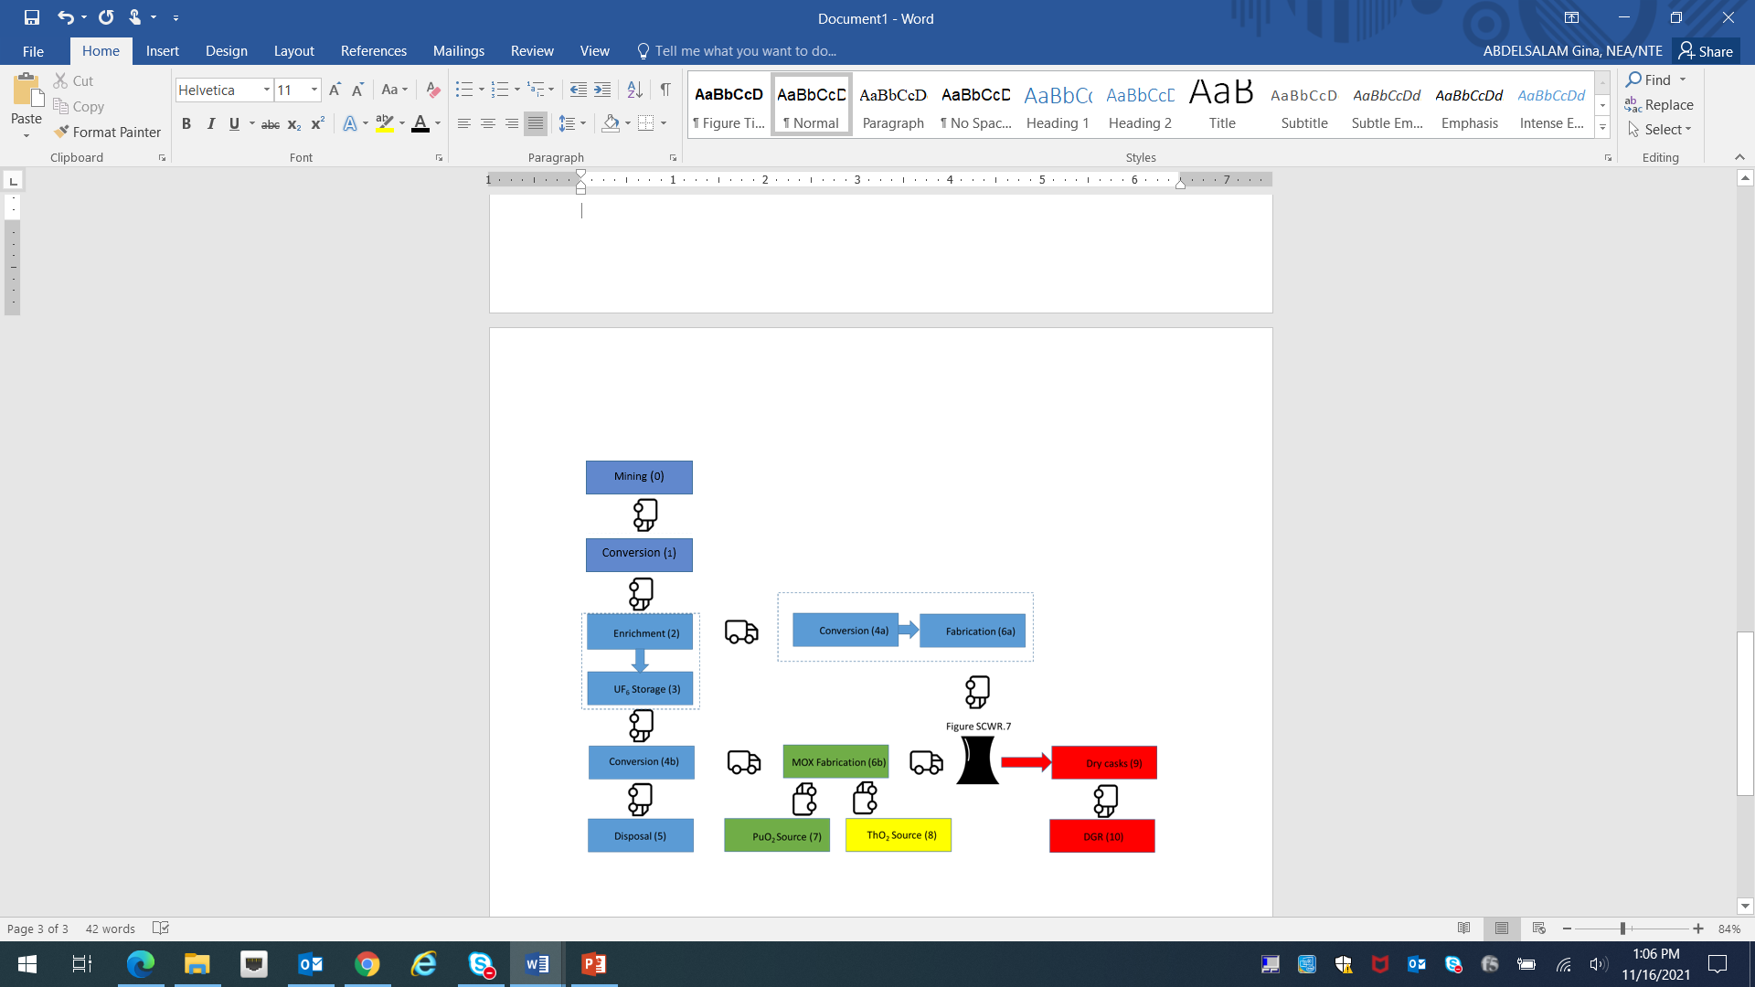

**Figure 8: System Elements for all SCWR types**

Color coding of blocks in **Figure 8** and **Figure 10** is as follows:

Blue: Typical system elements of an enriched uranium fuel cycle

Green: System elements with plutonium

Yellow: System elements with thorium

Red: System elements relating to disposal

## 3.2 SCWRs with recycling in the fuel cycle

Currently the Russian fast-resonant reactor is the only SCWR with recycling, although future changes to the fuel cycles of the other SCWRs to include this element are foreseen.

Russian concept VVER-SCP-600 is being developed using solutions that have been tested at the operating VVER-1000 and BN-600 power units. The spent fuel pool is located inside the containment; fresh and irradiated fuel assemblies are transported under a layer of water. For VVER-SCP-600, a self-supply mode with fuel in a closed fuel cycle is being designed for mixed oxide uranium-plutonium fuel in the core, taking into account breeding in the end and side blankets. All fuel assemblies in the core have the same design and differ by PuO2 content. Isotopic composition of plutonium in the mixed oxide uranium-plutonium fuel is similar to the isotopic composition of plutonium in the spent fuel of VVER-1000. All fuel assemblies of the side blanket have the same design.

Operation of VVER-SCP-600 is considered in a unified system together with the operation of VVER-1000/1200, BN-800/1200 with a closed fuel cycle.

Loading of fresh fuel into the spent and fresh fuel pool and unloading of spent fuel assemblies are carried out similarly to solutions for VVER-1000 plutonium-based REMIX fuel. The unloaded fuel assemblies are kept in the power unit's SNF pool for 5 years until the level of residual heat release allows transportation in dual-purpose transport packaging casks to the on-site storage. At the end of the interim storage period, casks with spent fuel assemblies are sent to the reprocessing plant. The fuel materials released as a result of reprocessing are sent to the manufacture of refurbished uranium-plutonium fuel for VVER-SCP-600.

**Fuel fabrication.** Fuel assemblies of the end and side blankets of VVER-SCP-600 can be manufactured at existing enterprises producing uranium fuel for VVER, RBMK and fast reactors. For the manufacture of mixed oxide uranium-plutonium fuel for the VVER-SCP-600 core, it will be necessary to build new production facilities.

**Fuel transportation and storage.** Fresh and spent fuel of VVER-SCP-600 reactor is supposed to be transported in dual-purpose transport casks and placed in the spent nuclear fuel storage facility at the NPP site. The cask moves around the NPP site by road train, on public roads by road or rail in special cargo ships or in cask wagons.

**Fuel processing.** SNF reprocessing is carried out by an aqueous hydrometallurgical method (PUREX) (**Figure 9**)

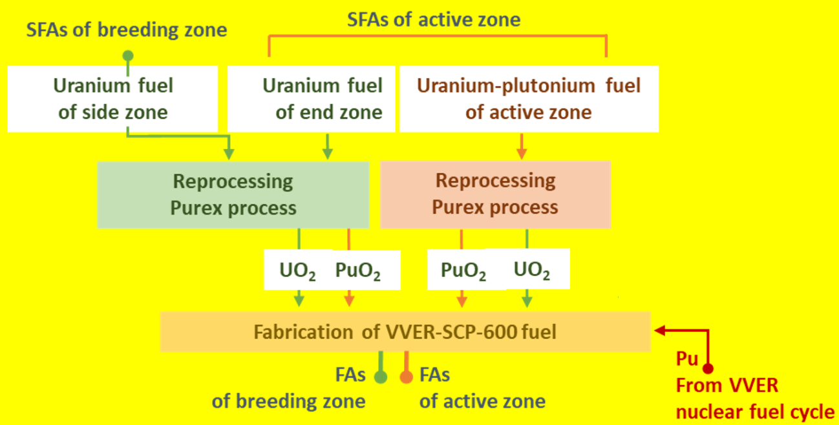

**Figure 9: VVER-SCP-600 SNF reprocessing [35]**

In the hydrometallurgical processing of VVER-SCP-600 spent nuclear fuel not recovered for recycling becomes the radioactive waste, which is conditioned following transfer to disposal. Waste conditioning is accomplished at reprocessing plant.

**Final disposal of radioactive waste.** Conditioned radioactive waste after reprocessing is subject to placement in near-surface storages and in deep disposal sites.

The reprocessing of spent fuel adds two system elements to the general description shown in **Figure 8**. These are the reprocessing plant for SCWR fuel and the transportation element of spent fuel from the reprocessing plant to the (existing) fuel fabrication facilities. The need for dry storage on site is removed. The specific block diagram of system elements is shown in **Figure 10**. The source of DU for top-ups, indicated in Figure 10, may be a connection to an existing enriched uranium fuel cycle or be connected to the external PuO2 fuel source (in this case assumed to be reprocessing facilities for conventional, non-supercritical water reactors).

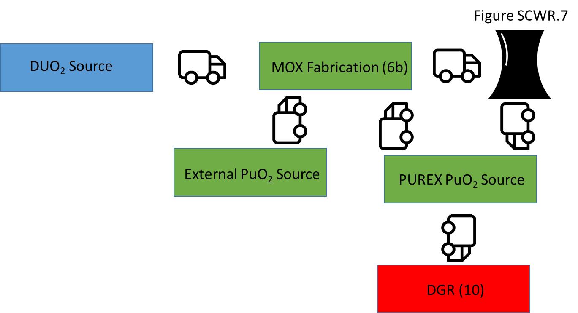

**Figure 10: System Elements of the VVER-SCP-600**

# 4. Proliferation Resistance Features

The intrinsic proliferation resistance of the SCWR fuel cycles have similarities to that of LWRs in the case of UO2 or MOX fuels. However, some of the SCWR designs have concentrated, high quality fissile material in their fuel cycle, either plutonium or uranium. It should be noted that some of the designs have the high-assay LEU (HALEU) of U-235 enrichment over 5% but less than 20%. This material is of slightly greater proliferation concern than current LEU fuel with U-235 enrichment in the 3%-5% range but the Safeguards actions would be very similar as there is still a need for further enrichment to reach the U-235 enrichment levels for HEU. In addition, SCWR designs with two different fuel cycles, containing both enriched uranium and MOX (such as the Chinese mixed-spectrum design), will have more system elements with PR&PP significance than most LWRs.

The higher fissile loadings mean that more plutonium is in the system, but this is mitigated by the higher burnups which reduce the attractiveness of the plutonium in the spent fuel by reducing the relative fraction of Pu-239. For MOX fuels, the rapid increase of Pu-238 at high burnups makes the plutonium less attractive for weapons use because of its high rate of spontaneous fission (0.12 GBq of spontaneous fissions per kg of 238Pu). However, regardless of the amount of spontaneous neutrons in the material, a nuclear device could always be constructed whose yield would be at least a kiloton [27]. For this reason, the mitigation of attractiveness offered by spontaneous neutron emission is minimal.

The thorium fuel cycle of the Canadian SCWR would have both positive and negative proliferation resistance characteristics. A negative feature, shared with the fast reactor SCWR concepts, is the requirement (at least initially) for significant quantities of plutonium to be present in the fresh fuel. Another negative feature is the creation of U‑233 by the production channel:

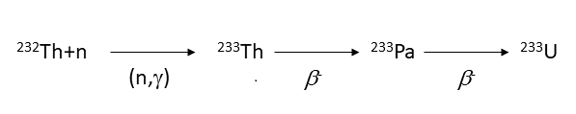

U‑233 is a highly attractive material for weapons use due to its very low spontaneous fission rate and can be separated from spent thorium fuel in a relatively pure form.

On the positive side, the creation of the isotope U-232, via the fast neutron (Q= 6.43 MeV) production channel:



occurs in parallel with the production of U-233. While the neutronic characteristics of U-232 do not impede the use of a U-233/U-232 mixture for weapons use, the decay scheme of U-232 (below)

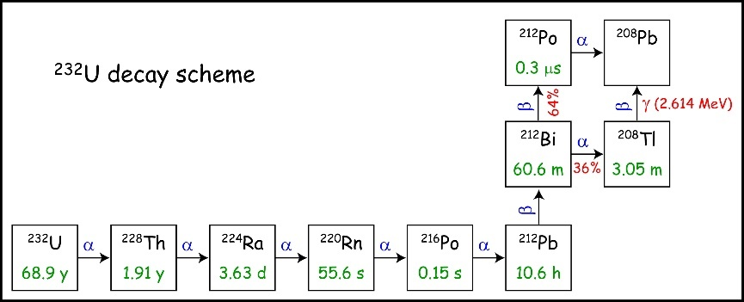

creates a very penetrating 2.614 MeV γ-ray from Tl-208 in 36% of decays. The activity of Tl-208 builds up quickly, starting with pure U-232, increasing by 0.3 GBq/g U-232 per day during the first three months. After 10 years, when the concentration of the Pu-238 daughter Th-228 is saturated, the Tl-208 activity is a maximum of 270 GBq/(g initial U‑232). The U-232/U-233 ratio of mid-burnup SCWR fuel is ~9x10-4 [28], so each g of U‑233 in spent fuel will have an associated Tl-208 activity of up to 270 x 9x10-4 = 2.4 x10‑1 GBq. The corresponding dose is about 80 µSv/hr, so the dose from Tl-208 alone is 64% of the IAEA “self-protection” level (1 Sv/hr) for spent fuel when a significant quantity (8 kg) of U-233 is present. This concept of “self-protection” is important in the physical protection part of PR&PP. The extent of the deterrence of this radiation has been debated, though, and it is argued [29] that U-233 would remain a highly attractive material for weapons use even with U‑232 present. Another non-proliferation idea, ‘salting’; the initial thorium with U‑238, prevents the acquisition of high purity U-233 by chemical means. However, this process has little effect on the attractiveness of the plutonium [29].

In some thorium cycles, the separation of Pa‑233 from spent thorium fuel can provide a very pure U‑233 stream uncontaminated by U-232 [30]. This vulnerability has not been seriously proposed as a proliferation resistance issue for solid‑fueled reactors (such as the SCWR), as the generation of a significant quantity of U‑233 by this route would require fuel reprocessing with a large mass throughput but on a very short timescale due to the 27-day half-life of Pa‑233.

A proliferation resistance aspect of any thorium fuel cycle is that it will have a lower production of plutonium isotopes than a uranium‑based fuel cycle. As well, the plutonium created will be relatively quite high in the amount of the isotope Pu‑238, since that is the first isotope created by the chain of captures and decays starting with Th-232 (see below).

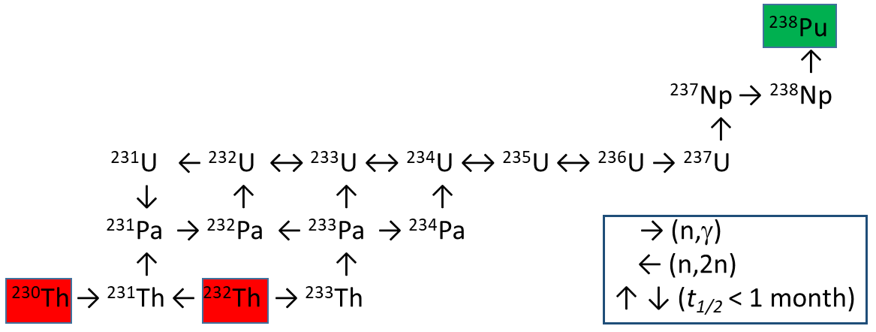

The presence of Pu‑238 has two implications for the attractiveness of plutonium: spontaneous fissions and heat. The effect of a high rate of spontaneous fissions on proliferation resistance is minimal, as discussed earlier in this Section. The effect of heat generation above is more interesting, posing considerable technological challenges to weapons above a level of 6-8% [31] [32] (easily exceeded in when isotopically pure thorium is irradiated). For an unadvanced proliferant group (either national or sub-national), the attractiveness of this material would be low [29]. However, current consensus is that “there are well developed means for addressing these problems” [27], and that the attractiveness of the material remains at least medium for groups with intermediate or higher technology and an advanced proliferant group would be able to construct a usable weapon with any plutonium up to the internationally recognized limit of 80% Pu‑238 [29].

Irrespective of the plutonium produced in SCWR fuel cycles themselves, proliferation resistance for any SCWR design with MOX fuel must consider the proliferation resistance and physical protection of the spent fuel reprocessing facility which produces the plutonium. In cases where active reprocessing is occurring to supply plutonium for the fuel cycle, Safeguards are more difficult to apply because the fissile material flows are not always in a unique identifiable unit form, amenable to unit counting and tag checks. In the European Union, EURATOM routinely and successfully applies Safeguards on the La Hague and Marcoule plants in France and, prior to the departure of Britain from the EU, on the Sellafield plant in the United Kingdom (UK). The IAEA applied limited safeguards to UK and French facilities in these nuclear weapon States and in Germany on the small-scale Karlsruhe facility [33]. The IAEA has also proposed and seen implemented safeguards to larger facilities such as the Rokkasho Reprocessing Plant[14] [*34*]. In the latter case, the IAEA attempted to do Safeguards-by-Design [35] but retroactive measures were still needed. That experience demonstrated that, while IAEA Safeguards can be applied in such a large bulk handling facility, it would be very advantageous economically if they had been considered more closely during design.

## 4.1 Concealed diversion or production of material

Diversion possibilities of the once-through fuel cycle, whether UO2 or MOX, are well established and similar to BWRs already under Safeguards. Transportation elements are not particularly vulnerable as chain-of-custody technologies are well evolved. The most vulnerable system elements would appear to be:

* The PuO2 source. This is most likely to be a fuel reprocessing plant, which represents a significant Safeguarding challenge because of the presence of liquid fissile solutions.
* Dedicated fuel channels in the reactor itself used for the irradiation of blanket elements.

### **4.1.1 Diversion of unirradiated nuclear material items**

SCWR designs with two different fuel cycles, such as the Chinese mixed-spectrum design containing both enriched uranium and MOX, will have more system elements with PR&PP significance than most LWRs.

Timely detection of the acquisition/diversion of nuclear material would be achieved in a similar fashion as that found in LWRs today. However, all the SCWR designs have concentrated, high quality fissile material in their fuel cycle, either plutonium or uranium enriched to higher than the 5% (HALEU). As noted earlier the HALEU and MOX in SCWR designs is about the same PR concern as LEU and MOX used in LWRs.

Fast reactor designs (for supercritical or other reactor types) can be notable for very high concentrations of plutonium in their fresh fuel. The total amount of plutonium in a fresh assembly will depend both on this concentration and the size of the assembly. The Canadian SCWR design, while not fast, also has a significant plutonium content in its fresh fuel assemblies. Individual fresh assemblies for these reactors would therefore represent an attractive possible target for diversion.

### **4.1.2 Diversion of irradiated nuclear material items**

For uranium based fuels, irradiated direct-use material (IDU) in SCWRs represents about the same level of concern as IDU in LWRs. In addition, thorium-based fuels have U‑233 as a concern.

The batch-refueling scheme offers limited access to the core but more attractive spent fuel (fewer items per SQ, non-uniform burnup). The most attractive diversion point is probably the point of transfer to interim or long-term spent fuel storage.

Proliferation resistance aspects of the SCWR designs with UO2 fuel should be similar to existing LWR and HWR designs, and plant design would incorporate safeguards that are also expected to be similar. With a target exit burnup of 60 GWd/tHM, average plutonium isotopic ratios in spent fuel will approximate that found in current LWR spent fuel, regardless of the design variant chosen. The spent fuel would have a range of burnups dependent upon refueling strategy.

One proliferation related difference between SCWR designs and LWR designs is the incorporation of depleted uranium blankets in some of the designs, such as the Chinese mixed-spectrum and the Russian and Japanese fast-spectrum reactors. The irradiation of such material has the potential to produce weapons grade plutonium (for short irradiations) or reactor grade plutonium (for longer ones) in a fuel section that is significantly less active and hence which will allow easier handling. In such cases, Safeguards measures such as the monitoring of irradiation times will be more important.

### **4.1.3 Undeclared production of nuclear material**

Undeclared production of nuclear material would not be easily achieved due to:

(a) the effectiveness with which access to the core can be monitored and thus safeguarded, and

(b) the effectiveness with which spent fuel inventories can be verified against production records and placed under containment and surveillance.

The thorium option presents new territory that will need to be examined from a proliferation resistance perspective. One issue of interest is the ability to remove thorium pins from the fuel bundle/array in the direct-self-recycle option, as this introduces a new target for diversion. The process of removal and refurbishment of the used thorium pins will need scrutiny to see how PR this process is and what safeguards measures are needed.

## 4.2 Breakout

Breakout vulnerabilities depend on the total amount of fresh fuel in the system, and the amount of spent fuel in a system having an internal reprocessing system element. Vulnerable elements are:

* The fresh fuel storage room at the reactor,
* The PuO2 source (if not external),
* The spent fuel pool and dry casks (if the PuO2 source is not external).

### **4.2.1 Diversion of existing nuclear material**

The breakout scenario in an SCWR facility is similar to that analyzed in current LWR facilities, but the amount of available plutonium, particularly in the fresh fuel which would require no reprocessing, in the system is larger at any one point in time in some designs. The status of Thorium/U-233 fuel designs and use will need analysis as numerous diversion paths, as noted above, can exist with varying attractiveness and ease of fulfillment depending on the design.

### **4.2.2 Production of the necessary weapons usable material**

In a breakout scenario, proliferant state wishing to remain undetected is limited by the time constraints (indicated by the Proliferation Time [18] measure) associated with the generation of weapons-grade or weapons-usable material. In the case of the most time-limited of breakout scenarios, the most attractive material would probably be associated with the lower burn-up material either in the core itself (for a partial-batch refueling scheme), or in the spent fuel where burn-up is not uniform.

## 4.3 Production in clandestine facilities

The SCWR technology is not expected to provide much utility, in excess of current LWR designs to which it has a strong resemblance, in aid of clandestine production facilities.

## 4.4 Overview of proliferation resistance features

The fuel cycle appears to be the most important distinguishing characteristic between SCWRs and a division of SCWRs into thorium, uranium and MOX‑based fuel cycles is proposed in Appendix 1. Using this classification, the PR&PP advantages and disadvantages of the SCWRs are noted based on the intrinsic proliferation resistance features identified for nuclear energy systems by the IAEA [18].

# 5. Physical Protection Features

The risks of theft or sabotage by non-state actors associated SCWR designs are expected to be similar to that of existing LWR designs.

## 5.1 Theft of material for nuclear explosives

All transportation system elements are vulnerable to theft, but the most desirable targets would be the transportation of the fresh materials:

* Transportation of enriched uranium between
  + Enrichment and Conversion, and between
  + Fabrication and the Reactor.
* Transportation of MOX between
  + the PuO2 source and MOX Fabrication, and between
  + MOX fabrication and the Reactor.

The next most desirable target would be:

* Transportation of spent fuel between the Dry Storage Facility and the DGR. However, in the recycling case (**Figure 10**) the conditioned material being transported (from the recycling facility) would be recycling plant wastes and would not be a proliferation target.

SCWR designs based on enriched uranium do not have materials that are particularly attractive for theft, as re-enrichment would be required to create weapons-usable material and such technology is unlikely to be available to non-state actors. Designs containing plutonium may supply a more attractive target. Shipments of plutonium between the plutonium source and the fabrication facility would be particularly vulnerable, as this material would not require separation. Shipment of fabricated MOX fuel rods from the fabrication facility to the reactor are also a vulnerable point, but separations technology would be required by the non-state actors in this case.

The thorium fuel cycle presents new territory that will have to be examined from a physical protection (PP) viewpoint, particularly if it involves materials with relatively high U-233 concentrations. Equally so, the attractiveness of plutonium in the spent fuel will need to be examined, particularly where low-burnup material is stored in the Spent Fuel Bay, or moved to interim dry storage.

## 5.2 Radiological sabotage

While sabotage would be an economic problem anywhere in the fuel cycle, any sabotage which had the result of dispersing particularly active radio-isotopes into the environment would be of particular concern. In this regard there are a number of vulnerable elements.

* The Reactor. This system element has a particularly high source term.
* If conversion and enrichment elements are present, there will be UF6 storage. UF6 is corrosive and sublimates at the relatively low temperature of 57°C. On contact with water or water vapor the toxic gas hydrogen fluoride (HF) is produced. Such accidents have historically resulted in some deaths. This element would appear to be a Physical Protection weak link if no proper security measures are taken.
* Spent fuel cooling pools. As Fukushima has demonstrated, interruption of cooling to the spent fuel cooling could result in a hydrogen explosion in the building with consequent dispersal of radio-nuclides.

The SCWR design variants are not expected to be different from Gen III+ systems. The main objective is to protect the plant (investment) and to protect the public and environment from radiological hazards caused by sabotage (external/internal). Enhanced intrinsic and extrinsic features that minimize the probability of damage to the plant will be used as much as possible to prevent damage to the plant. Every effort will be made to take advantage of such opportunities for improvement in the early design stages. If damage does occur, intrinsic and extrinsic measure should be in place to mitigate the effect to protect the public and the environment.

Special attention will be made to improvements that take advantage of the use of supercritical water as coolant. For example, the SCWRs have a reduced footprint, which makes it possible to use a smaller and more robust containment. Other measures that will be investigated are similar to those used in Gen III+ water-cooled reactors and include:

1) enhanced thermal inertia,

2) improved use of passive safety systems for reactivity control and shutdown and for heat removal,

3) redundant safety systems that are independent, and

4) enhanced severe accident management strategies.

Extrinsic prevention measures such as improved plant security will be considered at a later stage and is expected to involve institutes that have access to proprietary information that may not be readily available. It is anticipated that security experts will be involved in certain activities such as developing the plant layout and asked for a “wish list” of improvements that can be made to make plant protection easier.

The pressure tube concept offers a few safety improvements which are relevant to safety and therefore to protection against sabotage. The fuel channel design [2] allows the moderator to be a large, low temperature heat sink. Hence, penetrations of the calandria are less likely to lead to dispersal of radioactive material, and sabotage creating fuel overheating is also ameliorated.

Those designs where the extremely hot coolant is used to drive turbines directly (like BWRs, but different from many other LWRs) have the additional safety concern that impurities dissolved in the coolant, when activated in the core, are carried to the turbines. This may also be an issue of concern in radiological sabotage/core damage scenarios. The more conventional secondary coolant loop in the VVER-SCP-600 maintains the isolation of the core and eliminates this concern.

# 6. PR&PP Issues, Concerns, and Benefits

Compared with liquid metal cooled reactors, the SCWR has a number of general features different with respect to PR&PP. First, water is a clear liquid which allows optical surveillance of the fuel at any position, in the opened reactor, during fuel handling or in the storage pool, no matter if it is fresh fuel or spent fuel. The fuel assemblies and even each fuel rod can be numbered, labeled and thus identified without the need to remove them from the coolant or from the core. Second, water is chemically inert in the containment, such that a leak of coolant does not cause any secondary damage, and safety systems simply need to replace missing coolant.

Compared with gas cooled fast reactors, water stored inside the containment can provide a heat sink at least for several hours without the need for outside heat removal. Regarding thermal reactors, the use of low enriched fuel, which is less attractive for diversion, represents an additional advantage. Finally, as a consequence of more than 50 years of experience with more than 500 water cooled reactors, methods for surveillance and physical protection are well proven. Most of them can directly be applied to the SCWR.

There are a few concerns, however, with the fast reactor option. For example, if breeding assemblies are unavoidable, they should be blended with minor actinides to make them less attractive for diversion. (None of the current reactor concepts with breeding assemblies do this). Furthermore, the fresh fuel storage will include larger amounts of Pu, which will require more effort for protection and surveillance. Addressing this second concern will certainly require Safeguards to be considered during the design of the reactor building, so it is important that PR&PP be considered in parallel with the early stages of design.

# 7. References

[1] OECD Nuclear Energy Agency, “Technology Roadmap Update for Generation IV Nuclear Energy Systems”, January 2014.

[2] T. Schulenberg and L. Leung, “Super-critical water-cooled reactors”, Handbook of Generation IV Nuclear Reactors, Editor: I.L Pioro, Woodhead Publishing Series in Energy: 103, 2016.

[3] IAEA, “Status Report - Chinese Supercritical Water-Cooled Reactor (CSR1000)”, IAEA Advanced Reactors Information System (ARIS) Database, December, 2015.

[4] X. Cheng et al., “A Mixed Core for Supercritical Water-cooled Reactors”, Nuclear Engineering and Technology, 40(2), pp. 117-126, 2007.

[5] S. Ryzhov et al., “Concept of a Single-Circuit RP with Vessel Type Supercritical Water-Cooled Reactor”, Proc. 5th International Symposium on Supercritical Water-cooled Reactors, Vancouver, Canada, March 13-17, 2011.

[6] Y. Oka et al.,”Research and development of super light water reactors and super-fast reactors in Japan.”, Proc. 5th International Symposium on Supercritical Water-cooled Reactors, Vancouver, Canada, March 13-17, 2011.

[7] Jianhui Wu, & Yoshiaki Oka, Improved single pass core design for high temperature Super LWR, Journal of Nuclear Engineering and Design 267 (2014) 100– 108.

[8] Y. Oka and H. Mori (eds.), Supercritical-Pressure Light Water Cooled Reactors, DOI 10.1007/978-4-431-55025-9_1, Springer Japan 2014

[9] Q. Liu and Y. Oka, Single Pass Core Design for a Super-Fast Reactor, Ann. Nucl. Energy 80 (2015) p. 451-459

[10] J. Pencer and A. Colton, Progression of the Physics Conceptual Design for the Canadian Supercritical Water Reactor, 34th annual CNS Conference, Toronto, Canada, 2013 June.

[11] T. Schulenberg, L.K.H. Leung, Y. Oka, “Review of R&D for Supercritical Water Cooled Reactors Progress in Nuclear Energy”, Progress in Nuclear Energy, Vol. 77, pp. 282-299, 2014 (November).

[12] P.N. Alexseev, et al., “A Concept of VVER-SCP reactor with fast neutron spectrum and self-provision by secondary fuel”, Proc. of the International Conference on Fast Reactors and Related Fuel Cycles: Next Generation Nuclear Systems for Sustainable Development (FR17), Yekaterinburg, Russian Federation, 2017 June 26-29.

[13] Sedov A.A., et al., “NPP with SCW Nuclear Power Installation”, Proc. 10th International Symposium on Supercritical Water-cooled Reactors, Prague, the Czech Republic, March 15-19, 2021.

[14] P.N. Alekseev et al., “NFC Russia infrastructure readiness assessment for development of PSKD-600 power reactors”, Atomic Energy, Vol.130, No.1, May, 2021 (Russian Original Vol.130, No.1, January, 2021). DOI 10.1007/s10512-021-00764-1.

[15] Berkovich, V.J. et al., “Improved Heat Transfer in VVER-SCP Fuel Assembly”, Proc. 6th International Symposium on Supercritical Water-cooled Reactors, Shenzhen, Guangdong, China, March 03-07, 2013.

[16] M. Yetisir, J. Pencer, M. McDonald, M. Gaudet, J. Licht, R. Duffey, The Supersafe© reactor: A Small Modular Pressure Tube SCWR, AECL Nuclear Review, December 2012.

[17] International Atomic Energy Agency, “IAEA Safeguards Glossary, 2001 Edition”, International Nuclear Verification Series No. 3, Vienna, Austria, 2002.

[18] International Atomic Energy Agency, Proliferation Resistance Fundamentals for Future Nuclear Energy Systems, IAEA STR-332, IAEA Department of Safeguards, IAEA, Vienna (2002).

[19] Hopwood, J.M., Fehrenbach, P., Duffey, R.B., Kuran, S., Ivanco, M., Dyck, G.R., Chan, P.S.W., Tyagi, A.K., Mancuso, C., 2006. CANDU reactors with thorium fuel cycles. In: Proc. Pacific Basin Nuclear Conf., Sydney, Australia, October 15, p. 42.

[20] Dyck, G.R., Boczar, P.G., 2004. Fuel cycle flexibility in the ACR. In: Proc. Pacific Basin Nuclear Conference and Technology Exhibition, Honolulu, Hawaii, USA, March 21, 2004.

[21] Boczar, G.P., Dyck, G.R., Chan, P.S.W., Buss, D.B., 2002. Thorium Fuel Utilization: Options and Trends. IAEA-TECDOC-1319. IAEA, Vienna, p. 10.

[22] Hyland, B., Dyck, G.R., Edwards, G.W.R., Magill, M., 2009. Homogeneous thorium fuel cycles in CANDU reactors. In: Proc. Global 2009, Paris, France, September 6e11, 2009.

[23] The Proliferation Resistance and Physical Protection Working Group and the System Steering Committees of the Generation IV International Forum, “Proliferation Resistance and Physical Protection of the Six Generation IV Nuclear Energy Systems”, GIF, 2011.

[24] Generation IV International Forum, “Evaluation Methodology for Proliferation Resistance and Physical Protection of Generation IV Nuclear Energy Systems (Rev.6)”, GIF/PRPPWG/2011/003, September 2011.

[25] INFCIRC/153, paragraph 36 (c).

[26] Wolfgang Stoll "Thorium and Thorium Compounds" Ullmann's Encyclopedia of Industrial Chemistry 2012 Wiley-VCH, Weinheim. doi:10.1002/14356007.a27_001.

[27] “Nonproliferation and Arms Control Assessment of Weapons-Usable Fissile Material Storage and Excess Plutonium Disposition Alternatives,” DOE0NN-0007, pp. 37, 38, U.S. Department of Energy 1997

[28] J. Sharpe, “Methodology to Design Simulated Irradiated Fuel by Maximizing Integral Indices”, Nuclear Science and engineering, April 2016.

[29] C. Bathke, et al., “The Attractiveness of Materials in Advanced Nuclear Fuel Cycles for Various Proliferation and Theft Scenarios,” Nuclear Technology, Vol 179, July 2012, p. 5-30.

[30] J. W. Codding, J. R. Berreth, R. P. Schuman, W. H. Burgus, and R. A. Deal , Separation And Purification of A Gram Of Protactinium-233, IDO-17007, September 1964

[31] G. Kessler, Plutonium Denaturing by Pu-238, Nuclear Science and Engineering 155:1 53-73, 2007

[32] G. Kessler et al.,“A new scientific solution for preventing the misuse of reactor-grade plutonium as nuclear explosive,” Nucl. Eng. Des. 238, 3429–3444, 2008

[33] IAEA, “International Safeguards in the Design of Nuclear Reactors”, Nuclear Energy Series NP-T-2.9, 2014.

[34] Johnson, S.J., et al., “Development of the Safeguards Approach for the Rokkasho Reprocessing Plant”, International Atomic Energy Agency Symposium on International Safeguards Verification and Nuclear Material Security, IAEA-SM-367, Vienna, Austria, 2001.

[35] U.S. Congress, Office of Technology Assessment, Nuclear Safeguards and the International Atomic Energy Agency, OTA-ISS-615, Washington, DC: U.S. Government Printing Office, June 1995.

# APPENDIX 1: Summary of PR relevant intrinsic design features

Please refer to IAEA-STR-332 [18] for full explanations and complete definitions of terms and concepts

| **Summary of PR relevant Intrinsic design features** | **Thermal Reactors with Thorium Fuel**   * **Canadian SCWR** | **Reactors with Uranium Fuel**   * **European SCWR** * **Chinese thermal-spectrum** * **Chinese mixed-spectrum** * **Japanese thermal-spectrum** | **Reactors with MOX Fuel**   * **Chinese mixed-spectrum** * **Japanese fast-spectrum** * **Russian mixed-spectrum** * **Russian fast-resonant spectrum** |
| --- | --- | --- | --- |
| **Features reducing the attractiveness of the technology for nuclear weapons programs** | | | |
| 1. The Reactor Technology needs an enrichment Fuel Cycle phase | No uranium enrichment. | Yes | Yes (Chinese mixed-spectrum)  No (fast spectrum reactors) |
| 2. The Reactor Technology produces SF with low % of fissile plutonium | No | Yes | No |
| 3. Fissile material recycling performed without full separation from fission products | No recycling | No recycling | No. Either no recycling (other reactors) or full recycling and separation (Russian fast-resonant design with closed fuel cycle) |
| **Features preventing or inhibiting diversion of nuclear material** | | | |
| 4. Fuel assemblies are large & difficult to dismantle | Yes. | Yes. | Yes. |
| 5. Fissile material in fuel is difficult to extract | Yes. Thorium is difficult to reprocess. “Flourine volatility” not demonstrated at large scales yet. | No. PUREX is a mature technology. | No. PUREX is a mature technology. |
| 6. Fuel cycle facilities have few points of access to nuclear material, especially in separated form | Possibly. Separated plutonium may be required to move between reprocesing and fuel manufacturing facilities. | Possibly. Enriched uranium may be required to move between enrichment and fuel manufacturing facilities. | Possibly. Plutonium for fresh fuel can be sourced from spent fuel. |
| 7. Fuel cycle facilities can only be operated to process declared feed materials in declared quantities | No recycling. | No recycling. | No recycling (other reactors).  Yes for Russian fast-resonant concept VVER-SCP with closed fuel cycle. |
| **Features preventing or inhibiting undeclared production of direct-use material** | | | |
| 8. No locations in or near the core of a reactor where undeclared target materials could be irradiated | Yes. | Blanket exists for Chinese mixed-spectrum core design  No blankets defined for other designs | Blankets exist for these designs. |
| 9. The core prevents operation of the reactor with undeclared target materials (e.g. small reactivity margins) | No. | No. | No. |
| 10. Facilities are difficult to modify for undeclared production of nuclear material | Yes. | Yes. | Yes. |
| 11. The core is not accessible during reactor operation | Yes. Top header of cooling water blocks access to fuel | Yes. Top header of cooling water blocks access to fuel | Yes. Top header of cooling water blocks access to fuel. |
| 12. Uranium enrichment plants (if needed) cannot be used to produce HEU | n/a | No. | No. (Chinese mixed spectrum)  n/a Other designs. |
| **Features facilitating verification, including continuity of knowledge** | | | |
| 13. The system allows for unambiguous Design Information Verification (DIV) throughout life cycle | DIV should be straight-forward. | DIV should be straight-forward. | DIV should be straight-forward. |
| 14. The inventory and flow of nuclear material can be specified and accounted for in the clearest possible manner | Yes. Similar to existing LWR, batch-fueled, once-through designs. | Yes. Similar to existing LWR, batch-fueled, once-through designs. | Yes. The mixed and fast spectrum reactors are largely similar to existing LWR, batch-fueled, once-through designs in this respect. The fast-resonant spectrum deisng, with reprocessing, si similar to LWR MOX-fueled designs with reprocessing.. |
| 15. Nuclear materials remain accessible for verification the greatest practical extent | Yes. Similar to existing LWR, batch-fueled, once-through designs. | Yes. Similar to existing LWR, batch-fueled, once-through designs. | Yes. The mixed and fast spectrum reactors are largely similar to existing LWR, batch-fueled, once-through designs in this respect. The fast-resonant spectrum deisng, with reprocessing, si similar to LWR MOX-fueled designs with reprocessing.. |
| 16. The system makes the use of operation and safety/related sensors and measurement systems for verification possible, taking in to account the need for data authentication | Yes. Similar to existing LWR, batch-fueled, once-through designs. | Yes. Similar to existing LWR, batch-fueled, once-through designs. | Yes. The mixed and fast spectrum reactors are largely similar to existing LWR, batch-fueled, once-through designs in this respect. The fast-resonant spectrum deisng, with reprocessing, si similar to LWR MOX-fueled designs with reprocessing.. |
| 17. The system provides for the installation of measurement instruments, surveillance equipment and supporting infrastructure likely to be needed for verification | Yes. Similar to existing LWR, batch-fueled, once-through designs. | Yes. Similar to existing LWR, batch-fueled, once-through designs. | Yes. The mixed and fast spectrum reactors are largely similar to existing LWR, batch-fueled, once-through designs in this respect. The fast-resonant spectrum deisng, with reprocessing, si similar to LWR MOX-fueled designs with reprocessing.. |

**THE GENERATION IV INTERNATIONAL FORUM**

Established in 2001, the Generation IV International Forum (GIF) was created as a co-operative international endeavor seeking to develop the research necessary to test the feasibility and performance of fourth generation nuclear systems, and to make them available for industrial deployment by 2030. The GIF brings together 13 countries (Argentina, Australia, Brazil, Canada, China, France, Japan, Korea, Russia, South Africa, Switzerland, the United Kingdom and the United States), as well as Euratom – representing the 27 European Union members and the United Kingdom – to co-ordinate research and develop these systems. The GIF has selected six reactor technologies for further research and development: the gas-cooled fast reactor (GFR), the lead-cooled fast reactor (LFR), the molten salt reactor (MSR), the sodium-cooled fast reactor (SFR), the supercritical-water-cooled reactor (SCWR) and the very-high-temperature reactor (VHTR).

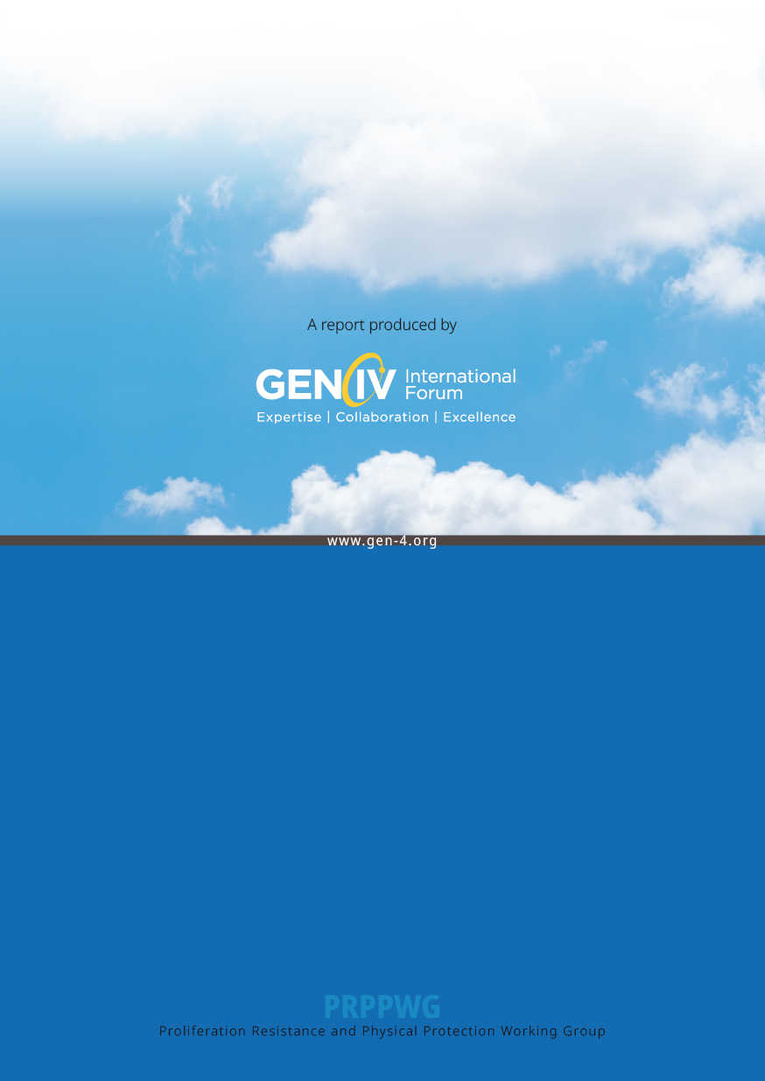

1. ‘Heavy element’.
2. This column has numbers from the 2014 book [8] (Table 2.5) and are for the High Temperature Single Pass core.
3. This column has numbers from the 2014 book [8] (Table 2.22) for average/maximum fuel burnup and is for the non-breeding single pass core. This core was redesigned later (see footnote 3) but the modifications were such that only slight changes to exit burnup are expected.
4. In reactor designs with reflectors, ‘fuel region/reflector region’.
5. [https://cordis.europa.eu/project/id/945234](https://urldefense.com/v3/__https:/cordis.europa.eu/project/id/945234__;!!P4SdNyxKAPE!UcNzVSGBTnY8ti716jR38uSAO7WxAm1EFG1RPEepoFlVeaHw4bcEH41A9Uxxrw$)
6. These numbers, and the associated analysis, come from the 2014 book [8] (Table 2.22). In 2015 published parameters [9] (Table 3) for the equilibrium core increased the plutonium concentration in the top part of the rod to 34%. However, the top part of the seed assembly is only 16.7% of the length of the whole fueled section, so this will increase the plutonium content of these assemblies only by a few percent.
7. “Significant Quantity” SQ, as defined [17] by the IAEA as “the approximate amount of nuclear material for which the possibility of manufacturing a nuclear explosive device cannot be excluded”. For Pu (containing less than 80% 238Pu) and for and 233U a SQ corresponds to 8 kg, A SQ is 25 kg 235U at enrichments of ≥20% 235U in U, 75 kg for enrichments <20% (or 10 t for natural U or 20 t for depleted U). See [17] for all details.
8. Supplied numbers were 12.5 kg fissile (239Pu+241Pu) plutonium and 2.44 SQ. The value for total plutonium shown above assumes 8 kg/SQ.
9. 129 assemblies per core (24 inner + 8 outer) x 4 + 1 divided by 5 batches to get an average batch size.
10. Time between fuel reshufflings of the core (when oldest fuel assemblies are removed)
11. The core studied had a seed burnup of 49.9 GWd/t and a blanket burnup of 32.7 GWd/t for a net burnup of 45.3 GWd/t (HE). The first and third numbers are from reference [7] and the middle number is based on a mass and energy balance calculation.
12. The U-235 content of spent fuel, and mid burnup fuel, are estimated here by assuming all burnup is U‑235 which supplies 1 MWd/g of energy. Plutonium production is roughly estimated at 1% of total heavy elements.
13. See reference [24] which defines ‘reactor grade’ plutonium as having 70% of the fissile isotopes (Pu‑239 and Pu-241) and ‘weapons grade’ as having 94% of the fissile isotopes in total weight of plutonium.
14. After numerous delays, the Rokkasho plant is expected to be operational in 2024 according to World Nuclear News, 26 February 2021.